2679-SO779K-38*38 V1.1
（EN779+IMX326_1440P-4MP）
AHD&TVI&CVI&CVBS&HD-SDI&EX-SDI-6-IN-1 Output

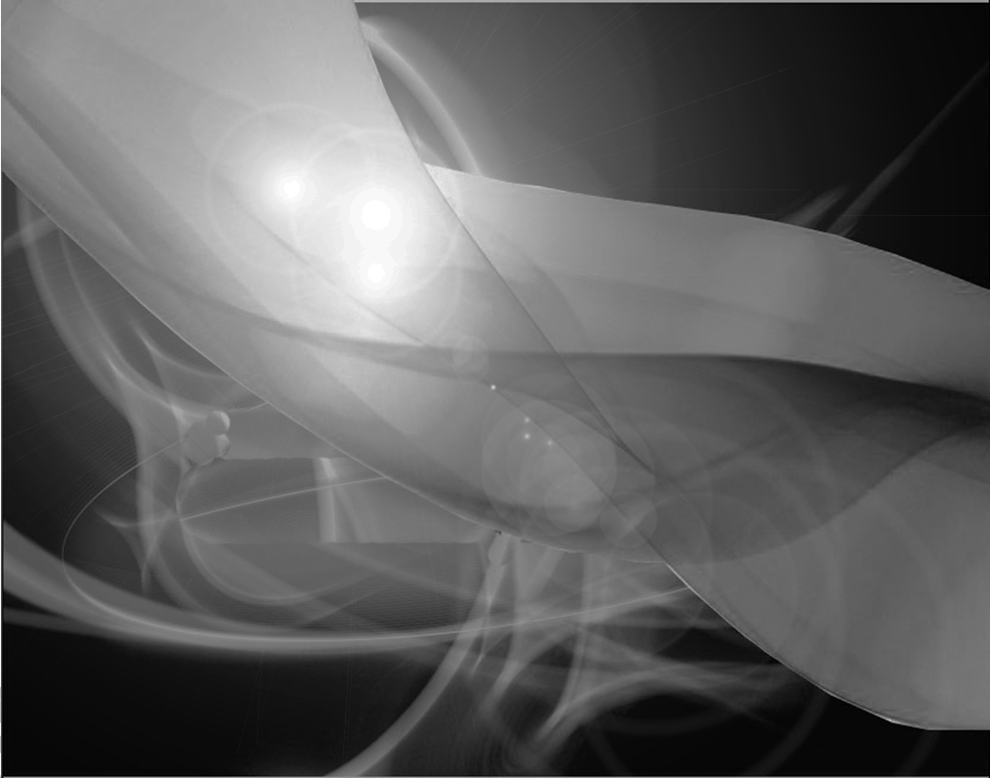

CMOS/MOS Single Board Camera
Versions No.：V1.1

Catalogue

Catalogue------------------------------------------------------------------------------------1

Specifications-----------------------------------------------------------------------------------2
1-1 Characteristic ----------------------------------------------------------------------------2
1-2 Effect Contract---------------------------------------------------------------------------5
SPECIFICATION---------------------------------------------------------------------------------5
CONNECTION-----------------------------------------------------------------------------------6
3-1 Interface Connection--------------------------------------------------------------------7
3-2 Interface Definition-----------------------------------------------------------------------9
OSD INTRODUCTION ------------------------------------------------------------------------10
4-1 Menu Introduction ----------------------------------------------------------------------11
4-2 Coaxial OSD Introduction ---------------------------------------------------------------16
PARAMETER -----------------------------------------------------------------------------------17
5-1 Main Functions and Parameter
ATTENTION ----------------------------------------------------------------------------------18

1FEATURE
1-1 Characteristic

●Adopt the video chip of Korean professional development team EN779 the latest version.
●The version is using CMOS IMX326， 1/2.9 inch, 6.15μm big pixel，Fan-out capability is 1440P/30p， be able to display FULL SCREEN 1440P High resolution image。With High resolution, and super sensitivity with good color reducibility, which could reach to 2K TVL. Itself Adapt to the changes from a wider range of color temperature. And adopting unique digital processing technology. Excellent low illumination image quality.
●Especially for dust, fog, haze, steam, vapor, such as bad weathers, this product has added defog function, to penetrate the fog to restore the original images of objects, suitable for forest surveillance, oil field surveillance, Rivers and Seas surveillance Border and Seacoast surveillance, Traffic Management Surveillance, License Plate Recognition, safety city, etc.
●Video Format: 1440P, the biggest resolution is 3096*2202。
● HLI(High Light Inhibition)：Super Eclipse , aimed at high light area and compensate to reach to the right exposure options on the specific areas.
●Smart 0SD(menu)operation system, powerful DSP memory function. The memory data will not lost when power off. The operation mode display function is simply, convenient and straightforward. The user could operate the product easily. The multi-language is available to choose.
● BLC(Back Light Compensation): Usually used for the image of strong contrast of brightness, to lets the darkness areas become more brightness.
could compensate the back light selectively on the dark parts, to make the whole objects luminance balance.
● Super ＷＤＲ: Super Wide Dynamic Range function，the bright side and dark side, as well as the window area on the same picture, the light could totally balance and the details visible.
● Motion Detection, Privacy Mask, Mirror, Reversal, D-Zoom function, etc.
● OSD: By providing convenience for the users of the OSD menu shown on the screen easy to operation the camera function.
● 3D-Digital Noise Reduction, Super Sensitivity(Sens-up)
● Support coaxial control signal, Video & OSD control signal mixing function.
● Support Auto Focus: AF 3X/4X/X8 selectable.
● Multi-signal output to choice: AHD/TVI/CVI/CVBS。
● Support menu switch signal output mode：First press OSD“Down”keyboard 3 times，then press OK keyboard、Loosen the button，then it will switch CVBS mode，the output is CVBS image; pressing OSD“UP”keyboard 3times，then press OK keyboard、Loosen the button，then it will switch to Analogue High Definition 4mp. On the SYSTEM/OUTPUT choose CVI, TVI, AHD signal output。
Attention：（To avoid DVR couldn’t compatible with the No corresponding mode output, if the default 4MP output couldn’t match with DVR, please choose 3 times “Down” keyboard and switch to CVBS when switching 4MP. Then choose one option on the ANALOG MODE switching HD_T/HD_C/HD_A 3 outputs on output, then exit the menu, 3 times “UP” keyboard and then “OK” keyboard, switching to 4MP.
● Switching HD-SDI and EX-SDI：Pressing 3times“Left keyboard”then press OK keyboard switching to EX-SDI; Press 3times“Right” keyboard then press OK keyboard, switching to HD-SDI。
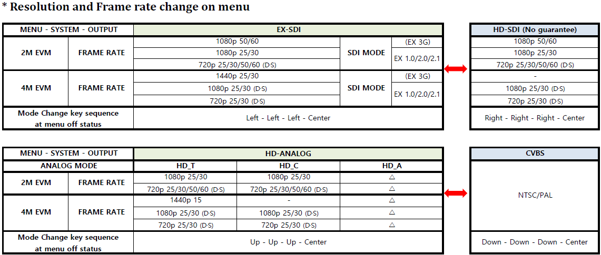

1-2
Effect of Contrast

►AF
It can fits 2MP/3MP/5MP +high precision motor+ HD IR-CUT, 2.8-8mm、2.8-12mm、6-22mm, etc. Automatic focus by the procedure, to realize the real high definition 32X D-Zoom.
2-1、 AF 3X、4X、8X
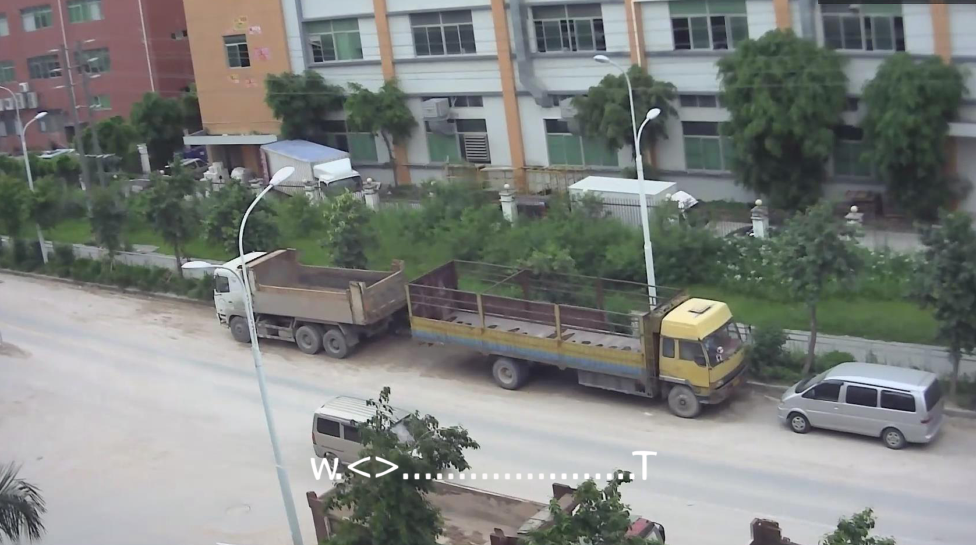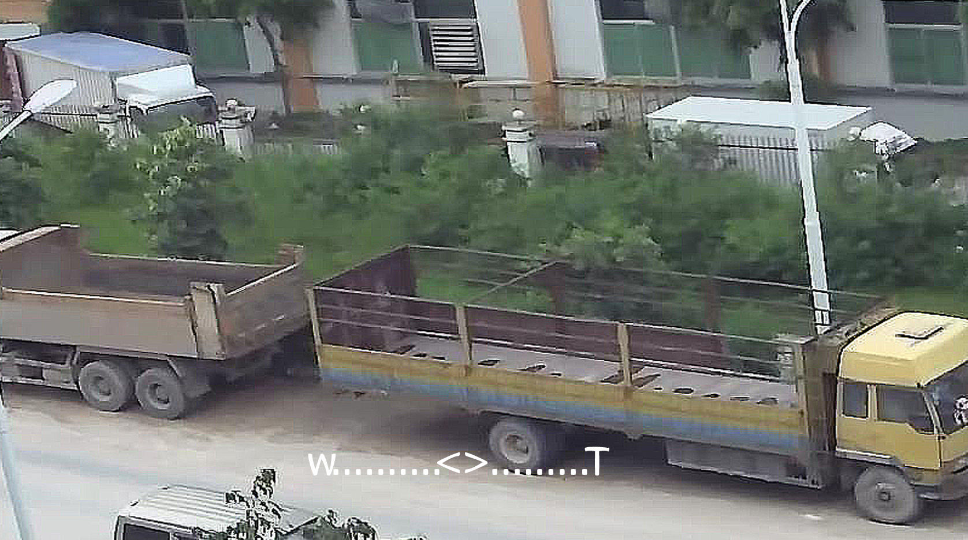
0X 4X

2-2、WDR
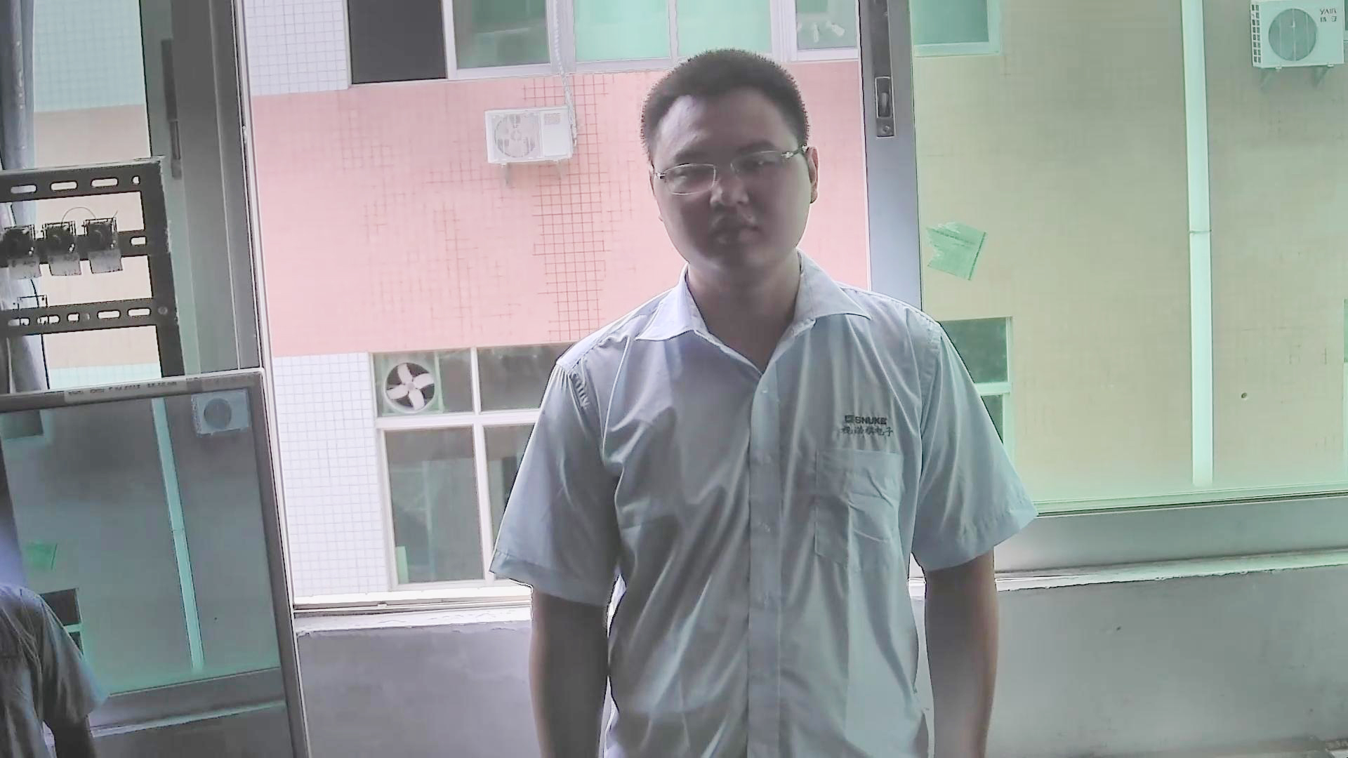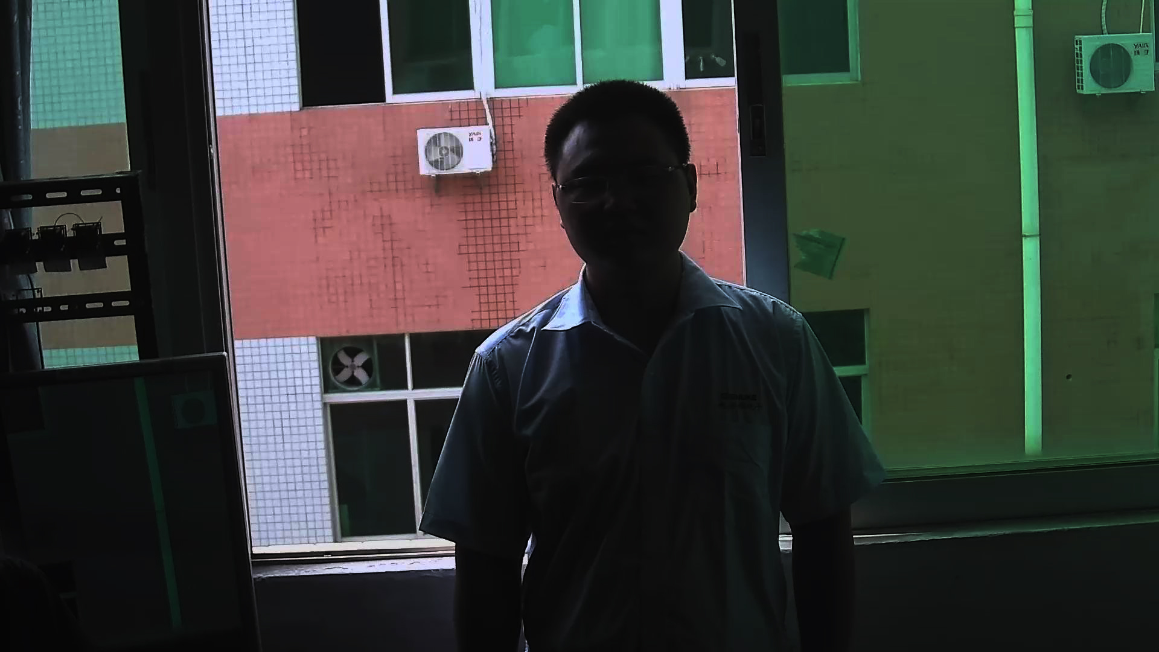
WDR Normal

►WDR
Ultra-wide dynamic capabilities in a very strong light, can see the features of the image contrast light in a small range, compared with the traditional 3:1 dynamic range. Super wide dynamic up to SNR 120Db, and the highest can reach 30fps.

►DEFOG
Using intelligent digital image
enhancement techniques, in the fog, dust, fog, haze, steam, water, security
surveillance over a long distance, it is well be have not a blind spot in 24-hour.

2-3、DEFOG
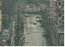
DEFOG Normal

►BLC
When the camera in the backlight environment, the picture will appear black image, the function can compensate backlight to make the image clear and bright as a whole. Restore you a whole picture, if it is on.
2-4、 BLC
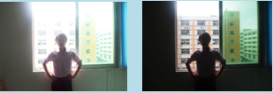
BLC Normal

1-2 Effect of Contrast
►AGC
High-magnification gain the signal intensity of the automatic control and automatic adjustment, guarantee the stability of image signal height, don’t have to worry about the installation of the complex environment.

2-5、 AGC
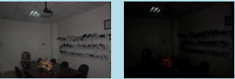
AGC Normal

►3D DNR
The noise reduction is a technology of between frames, realizing the 3 D image denoising. Make the images more pure and fine details! And closer to the actual effect of the human eye can see.

2-6、3 DNR
3D-DNR Normal

► MOTION DETECTION & ALARM
High Sensitivity, multi areas are
available to be set，on the meantime to
output the alarm signal or reminder.
Used for the Unmanned surveillance
video and automatic alarm. According
to the camera different frame rate
capture， the image will be calculated
and compared according to a certain
algorithm by DSP, Such as Abnormal
movement，Make a prompt or Alarm
reaction。

2-7、MOTION ALARM
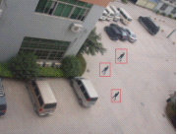

2-8、 Sens-Up
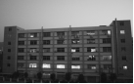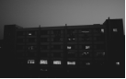
Sens-Up Normal

透雾画面 普通摄像机效果

►SENS-UP
The use of multiple frames overlap accumulated together to achieve a clearer, more details, making more brightness for the image in the night vision environment.

2 SPECIFICATION：

2-1
Appearance
PRODUCT Pros and Cons PICTURES
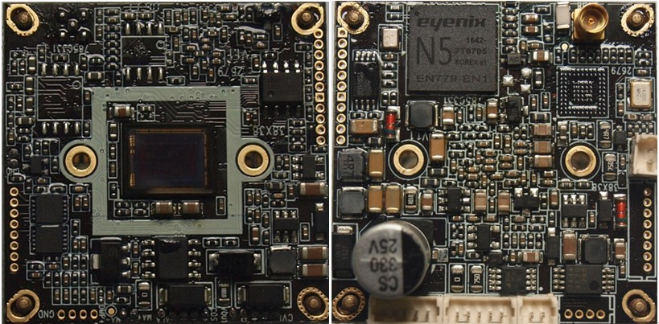

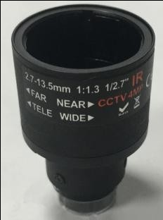

2-2
Size Diagram
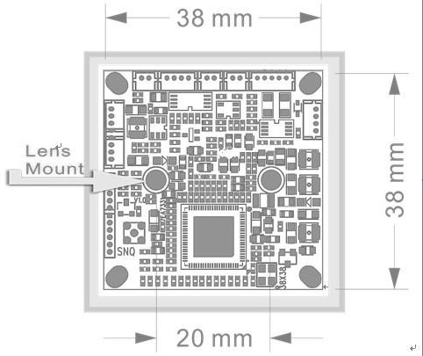
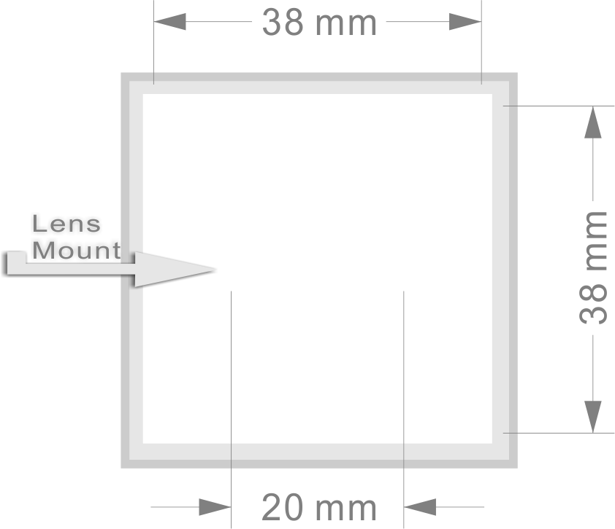
Notice.
1、Before installation, please confirm the assembly machine cavity screw holes are consistent with the product of hole size.
2、Installation please use type of screws: PM2*6/KM2*6
3、Install metal conductor is not permitted in touch motherboard components and circuitry, more do not have one on the direction of tension caused imbalance of installation makes the motherboard variant, it will cause circuitry breaking and damage the module.

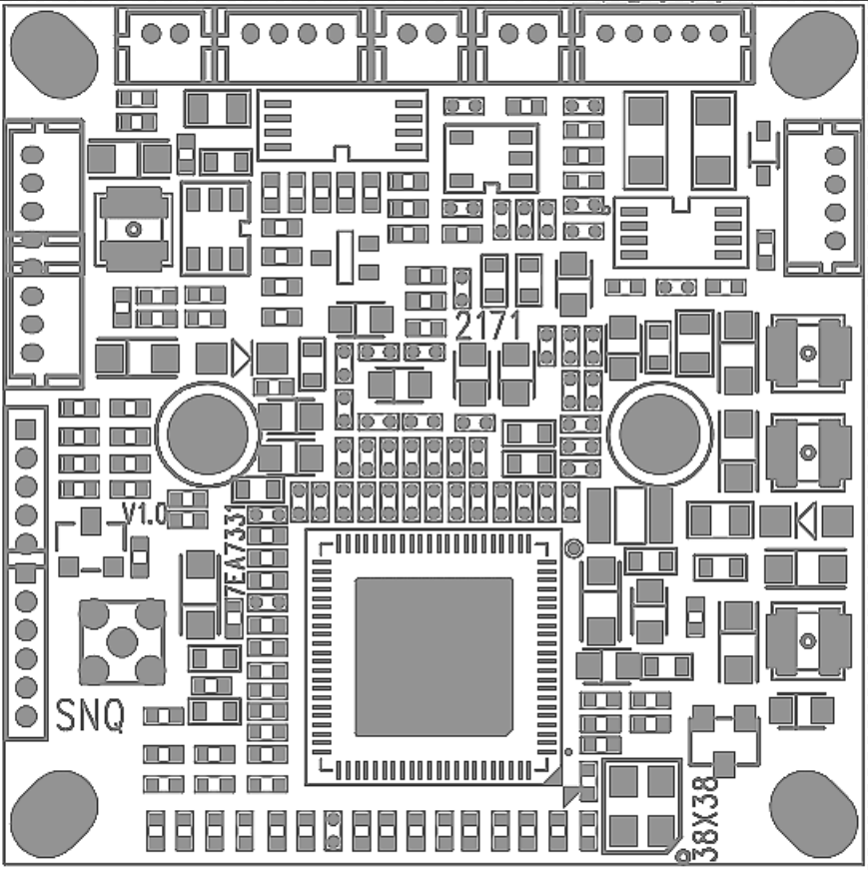

PCB Size | Thickness | PCB Version
38*38MM | 1.6MM | V1.1

3-1 CONNECTION
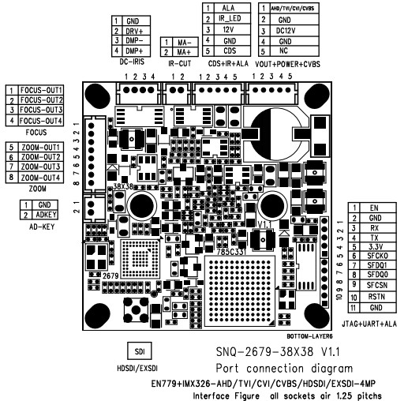

LED Board connection
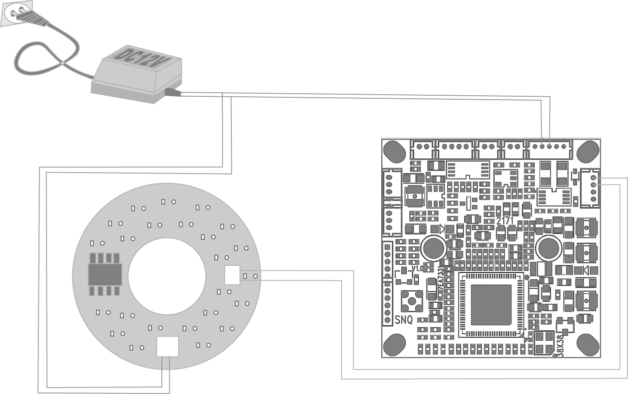

Note：
1：In strict accordance with the product order to wiring diagram, or it will damage the module
2：When using infrared lamp on the night of external control switch, as is shown in the picture on the right connection, generally high level (1.7v-8v)and the day and night option of mainboard model must be set up to EXTERN, at the same time you can change the mainboard menu options, EXTER S/W make CDS low-level action!

3-2
Interface Definition

Pin Definition
Connector | NO. | PIN Name | Description | IN/OUT
CVBS+POWER+VOUT | 1 | NC | NC | ----
 | 2 | GND | Ground | ----
 | 3 | DC12V | DC 12V INPUT | ----
 | 4 | GND | Ground | ----
 | 5 | CVBS | AHD/TVI/CVI/CVBS OUT 4选1
KEY | 1 | GND | DC IRIS control : GND
 | 2 | ADKEY | ADDEY OUT
DC-IRIS | 1 | GND | Control : GND | ----
 | 2 | DR+ | Control : drive+ | ----
 | 3 | DMＰ- | DC IRIS control :DAMP- DC IRIS | ----
 | 4 | DMＰ+ | DC IRIS control :DAMP+ DC IRIS | ----
IR-CUT | 1 | MA- | -DC Motor day and night control | ----
 | 2 | MA+ | + DC Motor day and night control | ----
FOCUS | 1 | FOCUS-B- | FOCUS | ----
 | 2 | FOCUS-B+ | FOCUS | ----
 | 3 | FOCUS-A+ | FOCUS | ----
 | 4 | FOCUS-A- | FOCUS | ----

ZOOM | 5 | ZOOM-B- | ZOOM | ----
 | 6 | ZOOM-B+ | ZOOM | ----
 | 7 | ZOOM-A+ | ZOOM | ----
 | 8 | ZOOM-A- | ZOOM | ----
JTAG+485 | 1 | EN | Burning Program& Communication Interface  软件烧录&通讯端口
 | 2 | GND |  | ----
 | 3 | RX |  | ----
 | 4 | TX |  | ----
 | 5 | 3.3V |  | ----
 | 6 | SFCKO |  | ----
 | 7 | SFDQ1 |  | ----
 | 8 | SFDQ0 |  | ----
 | 9 | SFCSN |  | ----
 | 10 | RSTN |  | ----
 | 11 | GND |  | ----
CDS+IR_LED | 1 | CDS | External day and night control signal input External day and night control signal input ，L ：CDS LEVE＜+1.7V H ：+1.7V≤ CDS LEVEL≤ +8V (active | ----
 | 2 | GND | Ground | ----
 | 3 | +12V | SUPPLY LED | ----
 | 4 | IR-LED | signal Smart ＩＲ Control | ----
 | 4 | ALA | ALARM IN | ----

４OSD MENU INTRODUCTION：
  - OSD Instruction

- OUTPUT 2-MOTOR
2-MOTOR
►OUTPUT Option is not selectable, show AHD signal, respectively are CVBS/CVI/TVI/AHD
►Choosing “Auto Iris” according to the operation environment choice model.
► Choosing “Fix Iris” according to the operation environment choice model.

OUTPUT TVI
IRIS ELC
2-MOTOR
EXPOSURE
BACKLIGHT OFF
DAY&NIGHT Outer
Color
DNR Middle
IMAGE
MOTION OFF
SYSTEM
EXIT SAVE

Automatic Focus
►AF MODE: AF include Auto and Manual mode.
SCANNING: Lens adjustment range (FULL/HALF)
ONEPUH: Manual adjust lens once. SYNC TDN: Day and Night switch.
INITIAL: After using for a long time, there is deviation occurs, but it can’t be executed multiple times.
► AF operation: setting AF MODE MANUL, can via the menu up/down/left/right key to manual adjustment the lens;
Setting AF MODE AUTO, click the up or down key can zoom! When loosen the key, it will automatically finish automatic focus.
Note：the menu display 2-MOTOR and dose not display the FUCUS ADJ, when motherboard have autofocus function,

2. Automatic Focus
OUTPUT TVI
IRIS ELC
2-MOTOR
EXPOSURE
BACKLIGHT OFF
DAY&NIGHT Outer
Color
DNR Middle
IMAGE
MOTION OFF
SYSTEM
EXIT SAVE

AF MODE AUTO
SCANNING HALF
ONEPUSHAF ON
SYNC TDN ON/OFF
INITIAL ON
EXIT

EXPOSURE
► BRIGHTNESS: 0-20 selectable.
► SHUTTER：
AUTO/FLICKER/MANUAL, three kinds of choice model.
1/25、1/50、1/100、1/200、1/400、1/800、1/1600、1/3200、1/6400、1/12800、1/25600, 11, selectable.
AUTO：DEBLURE/NORMAL., selectable.
►SENS-UP: OFF、X2、X4、X8、X16、X32 selectable.
►AGC：0-20 selectable
Note：video system different and the shutter will different. The manual electronic shutter PAL is 1/25, when NTSC is 1/30.

3. EXPOSURE
OUTPUT TVI
IRIS ELC
2-MOTOR
EXPOSURE
BACKLIGHT OFF
DAY&NIGHT Outer
Color
DNR Middle
IMAGE
MOTION OFF
SYSTEM
EXIT SAVE

BRIGHTNESS
SHUTTER MANUAL
SENS UP X2
AGC
EXIT

BACKLIGHT
►BACKLIGHT： OFF/HLC/BLC/WDR, used in different environment.
► HLC: strong light inhibition.
0-20，8 kinds of highlight color, respectively black, customize/white, yellow, cyan, green, purple, red, blue.
► BLC:
H-POS: 0-20 horizontal starting point;
V-POS: 0-20 vertical ending point;
H-SIZE: 0-20 horizontal ending point;
V-SIZE: 0-20 vertical ending point;
►Super WDR:
WDR mode：LINE/FRAME
ROI Window WDR：ON/OFF
ROI ON：
WINDOW ZONE : 0-3
WINDOW USE : ON/OFF
H-POS: 0-2560
V-POS： 0-2560
H-SIZE： 0-2560
V-SIZE： 0-2560
High、Middle、Low selectable, Starting
30fps
Note: ideo signal will be stopped output, when WDR is ON.

4. BACKLIGHT
OUTPUT TVI
IRIS ELC
2-MOTOR
EXPOSURE
BACKLIGHT OFF
DAY&NIGHT Outer
Color
DNR Middle
IMAGE
MOTION OFF
SYSTEM
EXIT SAVE

H-Pos 6
V-Pos 4
H-SIZE 3
V-SIZE 3
EXIT

5． Day&Night
►Day&Night
► Switch settings of Day and Night mode.
► AUTO：automatically switch to day mode or might mode by camera module reflecting to the external light.
► COLOR：stay Day mode all the way.
► B&W：stay Night mode all the way.
► EXTERN： automatically switch to day mode or might mode by the IR illuminator reflecting to the external light.
►ANTI-SAT.: 0-20 smart IR overexposure control, the bigger the value is, the slighter the overexposure. 0-20 selectable.
► D＞N THRES & N＞D THRES： setting the day and night mode threshold for switching each other, 0-20selectable.
►DELAY： setting the switching time of day and night mode (Only available when mode is AUTO or EXTERN).

OUTPUT TVI
IRIS ELC
2-MOTOR
EXPOSURE
BACKLIGHT OFF
DAY&NIGHT Outer
Color
DNR Middle
IMAGE
MOTION OFF
SYSTEM
EXIT SAVE

红外灯 OFF
ANTI-SAT.
EXTERN SWNONE
D＞N THRES
N＞D THRES
Delay Low
EXIT

6． COLOR
COLOR
► AWB：MANUAL, AUTO, AUTOext, preset selectable.
► MANUAL：setting C-TEMP (color temperature) and R/B (red/blue) GAIN value, 0-20 selectable.
C-TEMP: 3000K/5000K/8000 selectable.
►AUTO: automatic white balance.
►AUTOext: automatic tracking white balance.
►PRESET: put the camera lens to one special environment, the camera will choose this environment as basic white balance.
►COLOR GAIN：0-20 selectable.

OUTPUT TVI
IRIS ELC
2-MOTOR
EXPOSURE
BACKLIGHT OFF
DAY&NIGHT Outer
Color
DNR Middle
IMAGE
MOTION OFF
SYSTEM
EXIT SAVE

AWB 手动
COLOR Gain
EXIT

7．DNR
DNR
►3D-DNR can improve image roughness in low- light level environment, OFF/LOW/MIDDLE/HIGH.
OUTPUT TVI
IRIS ELC
2-MOTOR
EXPOSURE
BACKLIGHT OFF
DAY&NIGHT Outer
Color
DNR Middle
IMAGE
MOTION OFF
SYSTEM
EXIT SAVE

IMAGE
► SHARPNESS: 0~10.
►GAMMA: Used to adjustment the monitor GAMMA value
0.45/0.55/0.65/0.75 selectable.
►COLOR GAIN：Could be set 0-20
MIRROR：ON/OFF.
FLIP：ON/OFF.
►ACE：D-WDR, OFF、LOW/MIDDLE/HIGH.
► DEFOG： ON-enter，processing fog in image, makes the image clear. ATUO and MANUAL options choices，HIGH/MIDDEL/LOW.
► PRIVACY：ON-enter，setting the mask area position and size；Can setting 16 boxes mask area（NO. 0-15）, BOX: ON-enter, ON/OFF hide the numbered mask.
Mask setting：
H-POS: 0-60 horizontal starting point;
V-POS: 0-34 vertical ending point;
H-SIZE: 0-60 horizontal ending point;
V-SIZE: 0-34 vertical ending point;
Mask brightness& color range: U&V: 0-20
TRANS: 0-3 levels transparence setting.

8．IMAGE

OUTPUT TVI
IRIS ELC
2-MOTOR
EXPOSURE
BACKLIGHT OFF
DAY&NIGHT Outer
Color
DNR Middle
IMAGE
MOTION OFF
SYSTEM
EXIT SAVE

SHARPNESS GAMMA 0.55
MIRROR OFF
FLIP OFF
ACE OFF
DEFOG ON
PRIVACY
EXIT

9． MOTION
MOTION
Setting the alarm area in the image to let the camera give out alarm signal when objects in alarm area is moving.
►DET WINDOW: 0-3area selectable， (WINODW ZOOM). Each area is independent programmable.
H-POS: 0-60 horizontal starting point;
V-POS: 0-34 vertical ending point;
H-SIZE: 0-60 horizontal ending point;
V-SIZE: 0-34 vertical ending point;
► DET TONE: 5 kinds of border settable.
► MORECT FILL: OFF/ON
►sensitivity：0-10 level selectable, the smaller value is, the more sensitive the camera is.
►MOTION OSD：ON/OFF, display red box in the monitor when detecting moving objects.
►TEXT ALARM: display text “MOTION” in the monitor when detecting moving objects.
►SINGNAL OUT: ON/OFF, give out 3.3V alarm signal when detection moving objects.
Note: The options will be displayed in the WINDOW DET, when the“MOTION OSD”is on.
OUTPUT TVI
IRIS ELC
2-MOTOR
EXPOSURE
BACKLIGHT OFF
DAY&NIGHT Outer
Color
DNR Middle
IMAGE
MOTION OFF
SYSTEM
EXIT SAVE

DET WINDOE
DET TONE 2
MORECT FILL OFF
SENSITIVITY
MOTION OSD OFF
TEXT ALARM OFF
SIGNAL OUT OFF
EXIT

10. SYSTEM
OUTPUT TVI
IRIS ELC
2-MOTOR
EXPOSURE
BACKLIGHT OFF
DAY&NIGHT Outer
Color
DNR Middle
IMAGE
MOTION OFF
SYSTEM
EXIT SAVE

SYSTEM
►COM.：RS-485
Communication setting ID: 0-255,
BAUDRATE: 2400/4800/9600/57600/115200 selectable.
►IMAGE RANGE： USER/FULL/COMP, the OFFSET of USER: 0-32.
►COLOR SPACE: HD-CbCr、YUY、SD-CbCr.
►FRAME RAGE：1080P/720P_ (25fps/30fps), selectable.
►Monitor：0-3, choose a different screen style.
►FREQ: NTSC/PAL.
►CVBS：ON/OFF.
►LAUGUAGE：multiple languages CHN [S], CHN，EN、JPN、KOR、ITA
►COLOR BAR：OFF/ON，used in color contrast test (color bar on screen).
►CAM TITLE： ON through up、down、left、right keys to set up letters or numbers, after been set editor is displayed in the upper right corner of the screen.
►RESET：Long press to restore factory settings.

COM. 60HZ
OUTPUT
Video Range FULL
COLOR SPACE HD-CbCr
Language CHN[S]
COLOR BAR OFF
CAM TITLE OFF
RESET ON
EXIT

4.2 Coaxial Signal Control and AF Instruction
（Manufacturer of DVR different, the operation interface and methods will be different, will be subject to actual use）
The following two points are in Duhua CVR coaxial control menu functions to control Automatic Focus.
- Setting Instruction
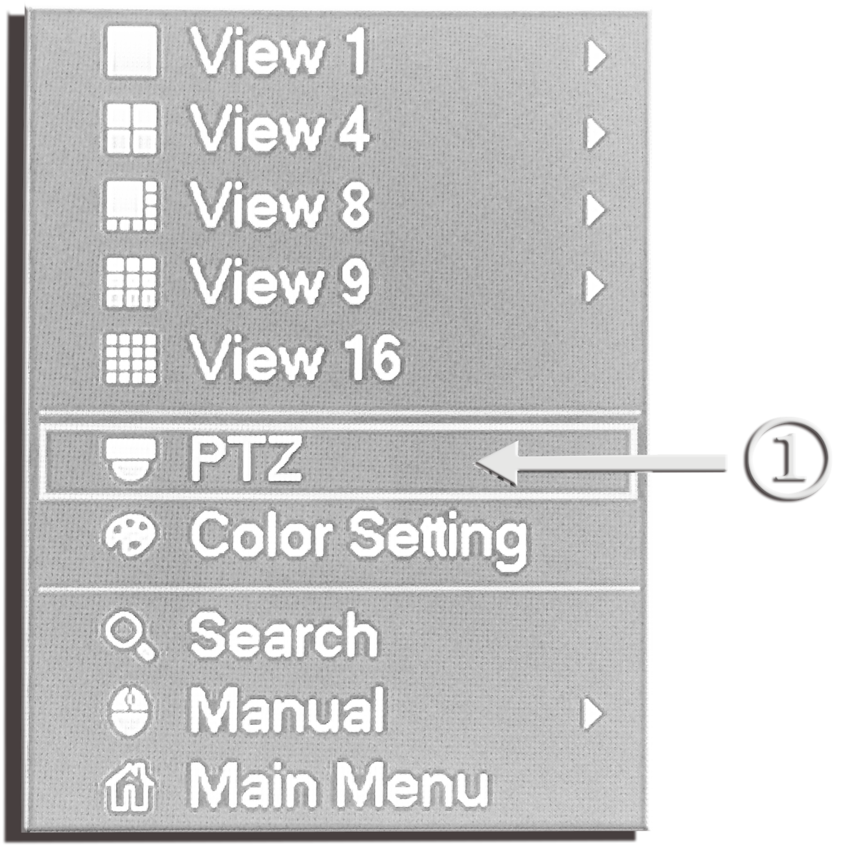

Figure 1
Figure 1：Click”①” can enter PTZ Control interface on the option of shortcut key menu of the DVR monitor. Then click “coaxial-control” into the Figure 2 interface.
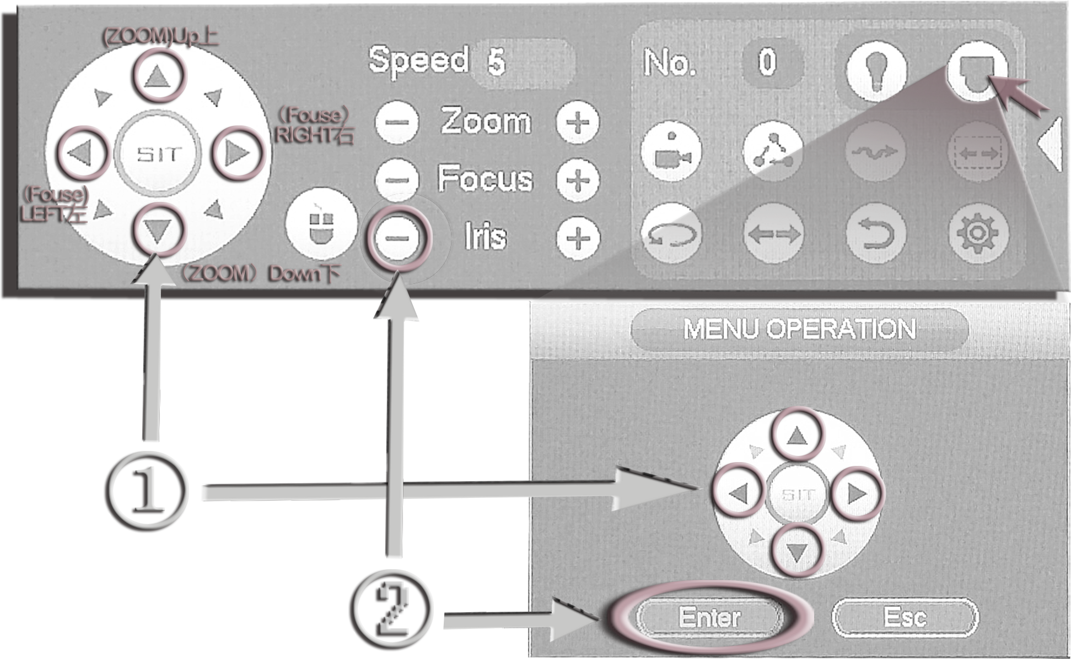

Figure 2
- Control Automatic Focus
- Figure 2: “①”respectively control the Focus Lens (Near/Far) and Zoom (Wide/Tele). Pressing the ZOOM “”/ “”buttons, and then loosening the button, when it was zoomed is you needed, and it will be enter automatic focus status. After pressed“②” enter interface of camera（“②”is an enter key）, the“①” keys becomes only“UP”“DOWN”“LEFT”“RIGHT”function to controls and selection menu
NOTE: 1. Default is manual mode after initialization, the method is: after enter the menu item selects 2-MOTOR, then click “INITIAL”, the system will enter the initialization adjust action (duration 1 minute).2. When you set menu function, normal exit, it unilaterally can automatically save the current setting, forced power cuts out will not be able to save the changes.

5.1 PARAMETER
Function &Parameter

MODEL | EN779+IMX326
Image Sensor | 1/2.9” SONY CMOS(IMX326)
Effective Pixels | 3096(H) × 2202(V)Approx. 6.87M pixels
Scanning System | Progressive
Resolution | Digital:1440P(30/15fps)
Min-illumination | Color:DSS:0.00008LUX, BW DSS: 0.00008 LUX
Video Output | Analogue high definition：AHD/TVI/CVI(1440P)及CVBS(960H)1Vp-p Composite Output(75 Ohm /BNC),4 language selectable, 1output
SDI | SDI output：HD-SDI/EX-SDI switchable
S/N Ratio | More than 42Db(AGC off)
ACE&WDR | Off/Low/Middle/High; WDR SNR: 120Db
Lens | Motor/DC/Manual/ fixed
Brightness | 0-20 steps
AGC | 0-20 steps
SENS-up | Off/X2/X4/X8/X16/X32
Shutter Speed | AUTO/MANUAL(1/50\60 ~ 1/60,000 sec)
Defog | Off/On, Low/Middle/High
BLC | Off/BLC
HLC | Off/HLC
Day &Night | Auto/Color/B&W/EXTERN
Color (AWB) | Auto/Auto ext/Preset/Manual
Monitor | 0/1/2/3
DNR | Off/Low/Middle/High
Mirror | Off/Low/Middle/High
H-V-REV | Off/On
Sharpness | Off/On
Motion | 0-10steps
Privacy Mask | 16Masks More
Language | Chinese/English/JPN/KOR/S polyglot language
Power(Max.) supply | DC12V ±10%<2.5W
Video Output | AHD/TVI/CVI/CVBS 4 IN 1
EX-SDI distance | BNC Cable 75-3 transmit reach more than 500m
Size | 38mm*38mm

６.ATTENTION：

POWER OFF THE EQUIPMENT：
If the equipment goes wrong, please power it off and send it back to factory for analysis.
Those repair instructions are only used for the reference of qualified repairmen.

NOTE：
To avoid electric shock, please don’t do any mending for description in the operation instructions.
Please carefully, read the following safety precaution.
● Don’t put the equipment on the surface
● Don’t install the equipment on the surface which lead to be exposed outside or under direct Sunshine, or close to warmer equipment or ultra-cold environment.
● Do keep it away from conductor.
● Do keep it away from liquid-leaking things.
● Don’t install it in place where is close to electromagnetic source.
● Don’t put any heavy objects on it.
● Do keep it away from radioactive rays
● Don’t mend the equipment by yourselves.

USER MANUAL AND INSTRUCTIONS, ALL SYMBOLS ARE USED FOR FOLLOWING PRUPOSES
REFERENCE：can provide help information lf how to use it.
NOTE：can bring damage to humans or other objects if do not operate according to instructions.

